Banking system simulation
Abstract :
A Banking System Simulation is a software-based model designed to replicate the fundamental operations of a real-world banking system. The primary objective of this project is to provide a simplified and efficient platform for managing basic banking activities such as account creation, deposits, withdrawals, balance inquiries, and transaction records. The system is developed to demonstrate how banking processes function in a structured and automated environment.
This simulation uses programming concepts and data structures to handle user data securely and efficiently. It allows multiple users to interact with the system, perform transactions, and maintain accurate account information. The project emphasizes reliability, data integrity, and ease of use, ensuring that all operations are executed correctly and systematically.
The Banking System Simulation serves as an educational tool for understanding the working principles of banking applications and software development. It helps students gain practical knowledge of coding, logic building, and system design. Overall, the project provides a foundation for developing more advanced financial systems with enhanced security and features.

Introduction
The Banking System Simulation is a software application developed to mimic the basic functions of a real-world banking system. In today’s digital era, banks rely heavily on computerized systems to manage customer accounts, process transactions, and ensure secure handling of financial data. This project aims to provide a simplified model that demonstrates how these banking operations are carried out efficiently using programming techniques.
The system allows users to perform essential banking activities such as creating an account, depositing and withdrawing money, checking account balance, and viewing transaction history. By automating these tasks, the simulation reduces manual effort and minimizes the chances of human error. It also ensures that all records are maintained accurately and can be accessed easily whenever required.
This project is especially useful for students as it helps in understanding the practical implementation of concepts like data structures, file handling, and user interaction in programming languages such as C or C++. It also introduces basic principles of security and data management in banking applications.
Overall, the Banking System Simulation acts as a foundational model for learning how modern banking software works, and it can be further enhanced by adding advanced features like online transactions, authentication systems, and database integration.
Objectives
- To simulate basic banking operations
The system aims to replicate real-life banking activities such as account creation, deposits, withdrawals, and balance checking.
- To maintain accurate customer records
It ensures that all user data and transaction details are stored and managed properly without errors.
- To provide a user-friendly interface
The objective is to make the system simple and easy to use so that users can perform operations without confusion.
- To minimize manual work and errors
By automating banking processes, the system reduces human effort and avoids calculation mistakes.
- To implement programming concepts effectively
The project helps in applying concepts like structures, functions, file handling, and data structures in C/C++.
- To ensure data security and integrity
The system aims to protect user information and ensure that transactions are performed safely.
- To allow multiple transactions efficiently
It supports repeated operations like deposits and withdrawals while updating account data correctly.
- To serve as a learning tool
The project helps students understand how real banking software systems work and how they are developed.
Hardware Software Requirements
- Operating System
The system can run on any standard operating system such as Windows, Linux, or macOS.
- Programming Language
C or C++ is used to develop the banking system simulation.
- Compiler
A compiler is required to compile and run the program. Examples include:
  - Turbo C++
  - GCC (GNU Compiler Collection)
  - Code::Blocks (with built-in compiler)
  - Dev-C++
- Text Editor / IDE
Any editor or Integrated Development Environment can be used to write and manage the code:
  - Code::Blocks
  - Dev-C++
  - Visual Studio Code
- File Handling Support
The system requires file handling features to store and retrieve customer data (accounts, transactions, etc.).
- Memory Requirements
Minimum 2 GB RAM is sufficient for smooth execution.
- Storage Requirements
At least 100 MB of free disk space is needed for program files and data storage.
- Libraries Used
  - Standard I/O library (stdio.h)
  - File handling library
  - String handling library (string.h)
  - (For C++) <iostream> and <fstream>
Requirements
- Processor (CPU)
Minimum Intel Core i3 or equivalent processor is sufficient to run the program smoothly.
- RAM (Memory)
At least 2 GB RAM is required (4 GB recommended for better performance).
- Storage (Hard Disk)
Minimum 100 MB of free disk space for storing the program and related files.
- Input Devices
  - Keyboard (for entering user data and commands)
  - Mouse (optional, if using an IDE)
- Output Devices
  - Monitor (to display program output)
  - Printer (optional, if you want printed records)
- System Architecture
32-bit or 64-bit system compatible with the compiler being used.
Features
- Account Creation
Users can create new bank accounts by entering basic details like name, account number, and initial balance.
- Deposit Money
The system allows users to deposit money into their account, and the balance is updated automatically.
- Withdraw Money
Users can withdraw money with proper balance checking to prevent overdrawing.
- Balance Inquiry
The system provides an option to check the current account balance at any time.
- Transaction Management
All transactions (deposit and withdrawal) are recorded and maintained for future reference.
- Data Storage
User details and transaction records are stored using file handling for permanent storage.
- User-Friendly Interface
Simple menu-driven interface that makes it easy for users to interact with the system.
- Multiple Account Handling
The system can manage multiple user accounts efficiently.
- Data Accuracy and Reliability
Ensures correct calculations and updates after every transaction.
- Security (Basic Level)
Basic validation is implemented to ensure only valid operations are performed.
Working Process
The Banking System Simulation works in a step-by-step manner to perform various banking operations efficiently:
- Start the System
The program begins execution and displays a menu with available options such as account creation, deposit, withdrawal, balance inquiry, and exit.
- User Selection
The user selects an option from the menu based on the operation they want to perform.
- Account Creation (if selected)
  - The user enters details like name, account number, and initial balance.
  - The system stores this information in a file or memory for future use.
- Deposit Operation
  - The user enters the account number and deposit amount.
  - The system verifies the account and updates the balance accordingly.
- Withdrawal Operation
  - The user enters the account number and withdrawal amount.
  - The system checks if sufficient balance is available.
  - If yes, the amount is deducted; otherwise, an error message is shown.
- Balance Inquiry
  - The user enters the account number.
  - The system retrieves and displays the current balance.
- Transaction Recording
  - Every transaction (deposit/withdrawal) is recorded and saved for future reference.
- Repeat Process
The system returns to the main menu after each operation, allowing the user to perform multiple transactions.
- Exit the System
When the user selects the exit option, the program terminates safely.
Technologies Used
- Programming Language
  - C / C++ is used to develop the system logic and implement banking operations.
- Data Structures
  - Structures (struct) to store customer details
  - Arrays or linked lists to manage multiple accounts
- File Handling
  - Used to store and retrieve account information permanently
  - Helps in maintaining transaction records
- Compiler
  - GCC (GNU Compiler Collection)
  - Turbo C++
  - Code::Blocks or Dev-C++
- Development Environment (IDE)
  - Visual Studio Code
  - Code::Blocks
  - Dev-C++
- Standard Libraries
  - For C: stdio.h, stdlib.h, string.h
  - For C++: <iostream>, <fstream>, <iomanip>
- Operating System
  - Windows / Linux / macOS (any OS that supports C/C++ compilation)
- User Interface
  - Console-based interface (menu-driven system)
Applications
- Educational Purpose
Used by students to understand how real banking systems work and to learn programming concepts like file handling and data structures.
- Training Tool for Beginners
Helps beginners and trainees practice banking operations in a simulated environment without real financial risk.
- Prototype Development
Acts as a basic model for developing more advanced banking software with additional features like online transactions and security systems.
- Small-Scale Banking Systems
Can be used in small organizations or local setups where only basic banking functionalities are required.
- Testing and Debugging
Useful for testing banking logic and identifying errors before implementing real-time banking applications.
- Automation of Records
Demonstrates how manual record-keeping can be replaced with automated systems for better accuracy and efficiency.
- Learning System Design
Helps in understanding how to design user-friendly systems and manage data effectively.
- Foundation for Fintech Projects
Serves as a starting point for building advanced financial applications like mobile banking, ATM systems, or digital wallets.
Advantages
- Reduces Manual Work
Automates banking operations like deposits, withdrawals, and balance checking, saving time and effort.
- Improves Accuracy
Minimizes human errors in calculations and record-keeping, ensuring correct results.
- Fast Processing
Transactions are completed quickly compared to manual systems.
- Easy Data Management
Customer details and transaction records are stored systematically and can be accessed easily.
- User-Friendly Operation
Menu-driven interface makes it simple for users to perform tasks without difficulty.
- Secure Data Handling (Basic Level)
Provides basic validation and protection for user data.
- Supports Multiple Accounts
Can handle and manage multiple user accounts efficiently.
- Educational Benefits
Helps students understand real-world banking operations and improve programming skills.
- Reliable System
Ensures consistent performance and maintains proper transaction records.
- Scalable Foundation
Can be upgraded with advanced features like online banking, authentication, and database integration.
Limitations
- Limited Functionality
The system usually supports only basic operations like deposit, withdrawal, and balance inquiry, lacking advanced banking features.
- Basic Security
It provides only minimal security and does not include strong authentication, encryption, or fraud detection mechanisms.
- No Real-Time Transactions
The simulation does not connect to real banking networks, so transactions are not processed in real time.
- Single-User or Limited Multi-User Support
Most basic versions cannot handle multiple users accessing the system simultaneously.
- No Database Integration (in simple versions)
Data is often stored in files instead of robust databases, which limits scalability and efficiency.
- Lack of Online Features
Does not support internet banking, mobile banking, or remote access.
- Error Handling Limitations
Basic programs may not handle all possible errors or invalid inputs effectively.
- Not Suitable for Real Banking Use
It is only for learning or demonstration purposes and cannot be used in real financial institutions.
- Limited User Interface
Usually console-based, which is less interactive compared to modern graphical interfaces.
- Scalability Issues
Difficult to expand for large-scale operations with many users and complex transactions.
Future Enhancements
- Advanced Security Features
Implement login authentication, passwords, OTP verification, and data encryption to improve security.
- Database Integration
Replace file handling with databases like MySQL or SQLite for better data storage, retrieval, and scalability.
- Graphical User Interface (GUI)
Upgrade from a console-based system to a user-friendly GUI using tools like Java Swing, Python Tkinter, or web technologies.
- Online Banking Support
Add internet-based features such as fund transfer, online payments, and account access from anywhere.
- Mobile Application Development
Develop a mobile app version for Android/iOS to make the system more accessible.
- Multi-User Access
Enable multiple users to access the system simultaneously with proper synchronization.
- Transaction History & Reports
Provide detailed transaction history, monthly statements, and downloadable reports.
- ATM Simulation
Include ATM functionalities like PIN verification, cash withdrawal, and mini statements.
- Notification System
Add SMS or email alerts for transactions, balance updates, and important notifications.
- Integration with Payment Systems
Connect with digital payment platforms (like UPI or card systems) for real-time transactions.

Algorithm: Banking System Simulation

Step 1: Start
Step 2: Initialize variables
Declare account number, name, balance
Set initial balance (e.g., 0 or minimum balance)
Step 3: Display Menu
Show options:
Create Account
Deposit Money
Withdraw Money
Check Balance
Exit
Step 4: Accept user choice
Step 5: Use decision structure (switch or if-else)
Case 1: Create Account
Input account number and customer name
Set initial balance
Display “Account Created Successfully”
Case 2: Deposit Money
Input deposit amount
Add amount to balance
Display updated balance
Case 3: Withdraw Money
Input withdrawal amount
Check if balance ≥ withdrawal amount
If yes → subtract amount from balance
If no → display “Insufficient Balance”
Case 4: Check Balance
Display current balance
Case 5: Exit
Terminate the program

Step 6: Repeat menu until user selects Exit

Step 7: Stop

FLOW CHART
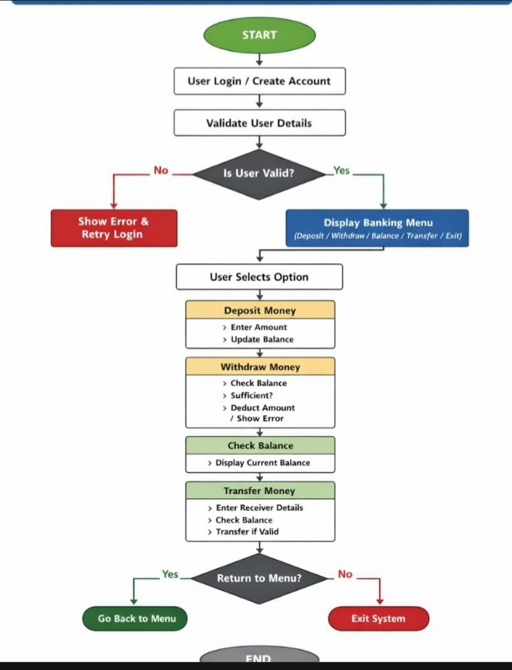

//BANKING SYSTEM SIMULATION CODE
#include <iostream>
using namespace std;
class BankAccount {
private:
string name;
double balance;
public:
BankAccount(string n) {
name = n;
balance = 0;
}
void deposit(double amount) {
if (amount > 0) {
balance += amount;
cout << "Deposited: " << amount << endl;
} else {
cout << "Invalid deposit amount\n";
}
}
void withdraw(double amount) {
if (amount <= 0) {
cout << "Invalid withdrawal amount\n";
} else if (amount > balance) {
cout << "Insufficient balance\n";
} else {
balance -= amount;
cout << "Withdrawn: " << amount << endl;
}
}
void checkBalance() {
cout << "Account Holder: " << name << endl;
cout << "Current Balance: " << balance << endl;
}
};
int main() {
string name;
cout << "=== Simple Banking System ===\n";
cout << "Enter account holder name: ";
getline(cin, name);
BankAccount account(name);
int choice;
double amount
while (true) {
cout << "\n1. Deposit\n2. Withdraw\n3. Check Balance\n4. Exit\n";
cout << "Choose an option: ";
cin >> choice;
switch (choice) {
case 1:
cout << "Enter amount to deposit: ";
cin >> amount;
account.deposit(amount);
break;
case 2:
cout << "Enter amount to withdraw: ";
cin >> amount;
account.withdraw(amount);
break;

case 3:
account.checkBalance();
break;

case 4:
cout << "Thank you for using the banking system.\n";
return 0;

default:
cout << "Invalid choice. Try again.\n";
}
}
}

METHODOLOGY

Methodology: Banking System Simulation

1. Requirement Analysis
First, identify what the system should do:
- Create a bank account
- Deposit money
- Withdraw money
- Check account balance
- Exit the system
This defines the scope of the simulation.

2. System Design
Design how the system will work:
- Use variables to store:
  - Account number
  - Customer name
  - Balance
- Use a menu-driven approach to interact with the user
- Apply control structures:
  - Loop (to repeat menu)
  - Conditional statements (if-else / switch)

3. Data Handling
- Store account details in variables (or structures if advanced)
- Maintain a balance that updates after each transaction
- Ensure data validity (e.g., no negative deposits)

4. Process Flow
- Start the program
- Display menu options
- Accept user input
- Perform selected operation:
  - Create account → initialize details
  - Deposit → add to balance
  - Withdraw → check balance, then deduct
  - Check balance → display current amount
- Repeat until user chooses Exit

5. Validation & Error Handling
- Prevent transactions before account creation
- Check for sufficient balance during withdrawal
- Reject invalid inputs (negative or zero amounts)
- Handle incorrect menu choices

6. Implementation
- Translate the algorithm into a programming language (C, Java, Python, etc.)
- Use functions (optional but recommended):
  - createAccount()
  - deposit()
  - withdraw()
  - checkBalance()

7. Testing
- Test each function:
  - Deposit works correctly
  - Withdrawal blocks insufficient balance
- Test edge cases:
  - Zero balance
  - Large inputs
  - Invalid choices

8. Output & User Interaction
- Display clear messages:
  - “Account Created Successfully”
  - “Insufficient Balance”
  - “Invalid Input”
- Show updated balance after each transaction

9. Maintenance & Improvement
- Add features like:
  - Multiple accounts
  - Transaction history
  - PIN/security system
  - File/database storage

